YANP
(Yet Another NKS Playground)

Philip Ronald Dutton
philiprdutton@gmail.com

The Playground: Imaging Software. Two simple image processing experiments are presented.

(1) Play with Filters

Typical “artistic” use of Find Edge Filter:
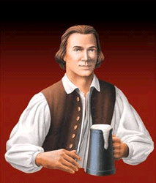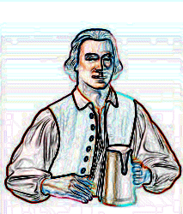

This time use a simple source image: (Use a single row of white pixels with one black pixel. The grid is shown for emphasis.)

Source image:

If we apply the standard edge filter once, then we find the following:

If we continue applying the find edge filter (saving the output at each step), then we can append each step’s output and easily see the elementary rule 90 CA output:

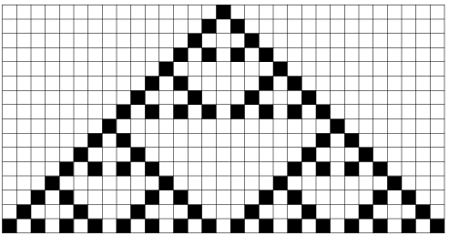

Hence, we can see that the Rule 90 CA can perform a very simple form of edge detection. It turns out that many of the elementary CAs can also perform basic edge detection. One can simply build a black and white bitmap image. If each row of pixels if used as initial condition to Rule 90 then the output of each pixel row’s rule 90 application can be combined to show the resulting edge detection output.

(2) Play with Gradients

Turning our attention to color gradients, we can find some interesting directions for experimentation. In imaging software there are often gradient tools available. Note that the simplest gradients are basic single color fills. Hence, using the ellipse tool to create a solid circle can be thought of as creating a spherical gradient (one which just so happens not to change colors). In the following line of experimentation a succession of gradient shapes will be drawn. The shapes might overlap. The default setup of most imaging software will simply overwrite whenever there is overlap. However, it is possible to use standard layer transfer modes. Transfer modes affect the way overlapping pixels affect each other.

Circles: (no interaction in the overlap)
Using the ellipse tool to create circles…

Gradients: (no interaction in the overlap)
Using the radial gradient tool (black as start color, white as end color)…



Gradients: (difference operator in the overlap)
Apply difference operator on overlapping pixels when using the radial gradient tool…

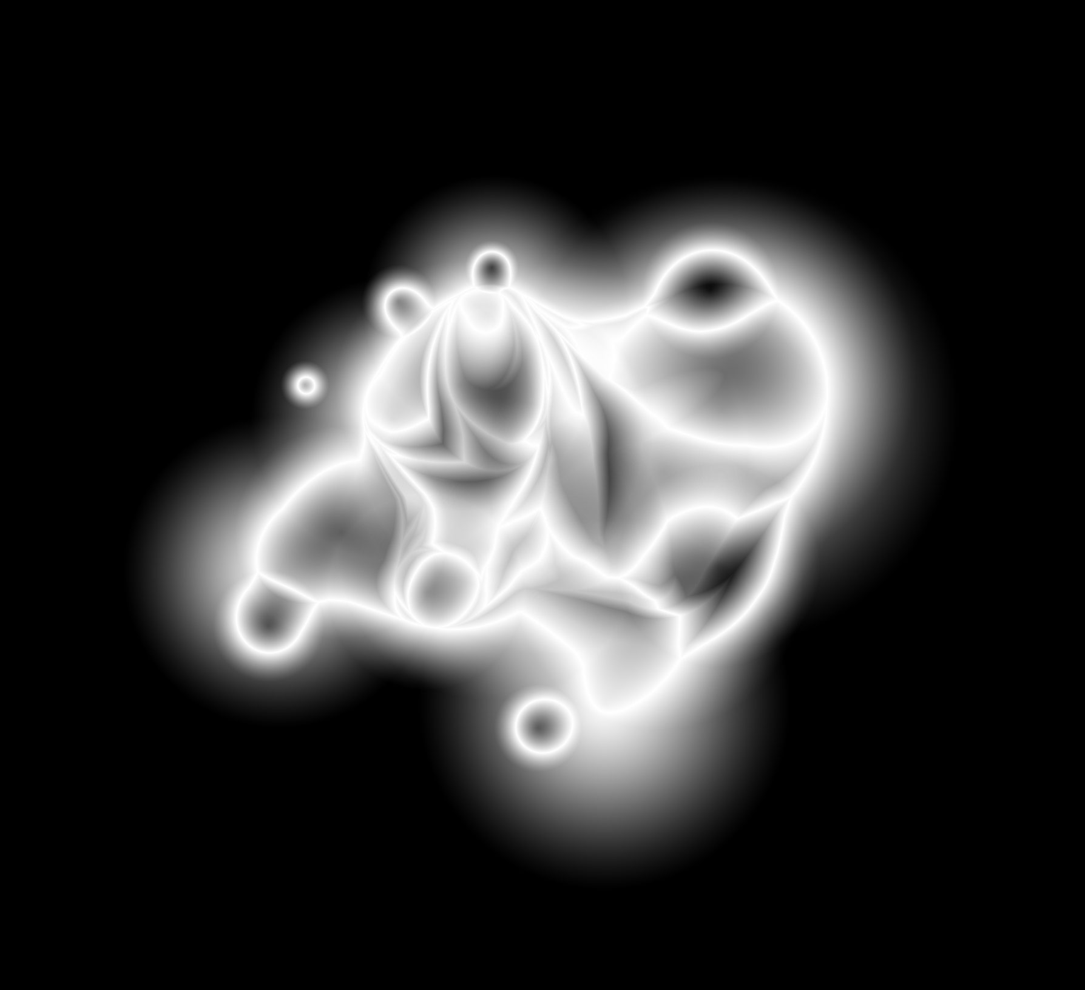

Notice the complicated imagery which is produced. Is it possible to find class 4 activity using this kind of setup (perhaps with a little bit of image processing programming)?

